February 2019

To the School Transportation Community:

The New York Association for Pupil Transportation (NYAPT) is pleased to announce a Scholarship opportunity that will enable five (5) New York State school transportation professionals to attend their first NYAPT Annual Conference.

The New York Schools Insurance Reciprocal (NYSIR) will provide funding to support scholarships for five (5) school transportation professionals who have never attended a NYAPT Annual Conference. Each $1,000 scholarship will subsidize (1) full conference registration (including evening events), (2) three nights lodging at the Marriott for the Conference, and (3) one Active NYAPT Membership. Scholarship recipients are responsible for their own travel costs, and incidental costs during the conference.

To see if you qualify for a scholarship, please review the application information attached and complete and submit the application form provided before May 17, 2019. Selections of scholarship recipients will be announced not later than June 14, 2019, to allow for registration, travel and related plans.

NYAPT appreciates the generosity of the New York Schools Insurance Reciprocal and we encourage you to avail yourself of this wonderful learning opportunity!

Sincerely,
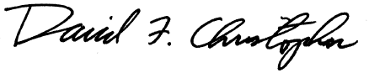
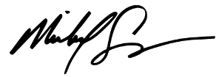
Michael Sweeney David Christopher
President, NYAPT Executive Director
NYAPT

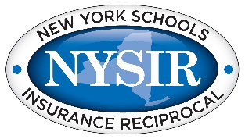THANK YOU TO THE NEW YORK SCHOOLS INSURANCE RECIPROCAL!

Purpose

To provide financial support for school transportation professionals to attend the Annual School Transportation Conference convened by the New York Association for Pupil Transportation.

NYSIR has made a contribution to NYAPT for this purpose and NYAPT will utilize these funds solely on behalf of eligible and qualified individuals selected pursuant to the application process.

Specifics
The NYSIR Scholarship program will provide funds for the Annual Conference registration, lodging for three nights at the Annual Conference, an Active NYAPT membership, and one ticket to the Annual Banquet. There will be as many as 5 scholarships awarded with one in each of five regional areas of the state. The NYSIR funding does not cover the incidental and travel costs for the selected individuals.

Eligibility

To be eligible for the scholarship, an individual must be employed by a school district, BOCES, private contractor, Head Start, ARC or other education institution or agency in the supervision, administration or management of school transportation programs and services. Individuals who provide training as School Bus Driver Instructors or Article 19-A Examiners are also encouraged to apply.

It is the intent of this scholarship program to award at least one scholarship in each of the following regional break-downs of the State using NYAPT Chapters as the boundaries for each region:
Region 1 Nassau County, Suffolk County, Lower Hudson
Region 2 Capital Area, Tri-County, Lake Champlain, Mid-Hudson
Region 3 Jeff-Lewis, Mohawk Region, Central NY, NYAPT North
Region 4 Southern Tier, RATSA, Wayne-Fingerlakes, Del-Chen-Ot
Region 5 Western NY, Chautauqua Co, Allegany Co, Cattaraugus Co, Steuben Co

Criteria

- Scholarships will be provided to individuals who have not previously attended a New York (NYAPT) Annual School Transportation Conference;
- Applicants must describe some steps they are trying to take to promote safety and how this conference will assist their efforts;
- Applicants must describe why they want to attend this annual conference.

Application and Selection Process

Applicants must complete the attached application form (attach additional sheets if needed to complete your responses) and it must be received at the offices of NYAPT by May 17, 2019.

MAIL TO: New York Association for Pupil Transportation
1764 Route 9, PO Box 356 / Clifton Park, NY 12065

Notification
Successful applicants will be notified in writing not later than June 14, 2019. Assistance will be provided in completing the registration process to take full advantage of the scholarship program.

APPLICATION FORM: NEW YORK STATE INSURANCE RECIPROCAL (NYSIR)
ANNUAL SCHOOL TRANSPORTATION CONFERENCE SCHOLARSHIP 2019

Name
Employer
Address
City/State/Zip
Phone Email Address
NYAPT Member:  YES  NO CHAPTER:
How Many School Buses in Your Fleet?

Discuss Something Special You Are Doing to Promote School Bus Safety This Year and How This Conference Attendance Will Help Your Efforts (additional sheets as needed):

Discuss Why You Want to Attend This Year’s Annual Conference (additional sheets as needed):

Offer Any Other Comments You Wish to Share (additional sheets as needed):

YES THIS WOULD BE MY FIRST ANNUAL CONFERENCE (initial):

SIGNATURE:

DATE: / /

NYAPT USE ONLY: RECEIVED: / /

